
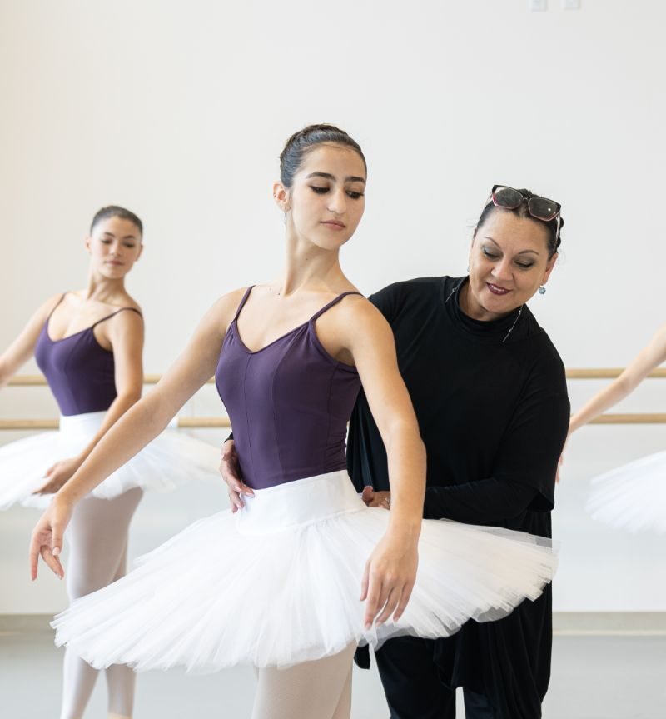



Student Handbook
2026-2027 School Year
Table of Contents
General Information…………………………………………………………………………………………………………………… 3
Registration and Financial Information………………………………………………………………………………………. 4
Withdrawal, Waitlist and Transfer Policy…………………………………………………………………………………… 5
Dress Code……………………………………………………………………………………………………………………………….. 6
Absence and Attendance……………………………………………………………………………………………………………8
Medical Conditions, Allergies and Injuries………………………………………………………………………………… 8
Safety and Security…………………………………………………………………………………………………………………… 9
Drop Off, Pick-up, Parking and Lobby Policies…………………………………………………………………………… 9
Class Observation…………………………………………………………………………………………………………………… 10
Evaluations……………………………………………………………………………………………………………………………… 10
Performances………………………………………………………………………………………………………………………….. 10
Student Resources & Benefits………………………………………………………………………………………………… 10
International Students…………………………………………………………………………………………………………… 11
Behavior and Etiquette Procedures………………………………………………………………………………………… 12

  School Hours |   School Calendar
Monday-Thursday: 8:30am-8:30pm
Friday: 8:30am-7:30pm
Saturday: 8:30am-3:00pm
Sunday: Closed
  Parent Portal |   OBS App

The Academy Program is for students 13+ as of September 1st. An audition is required to enroll in any of the Academy programs. Auditions are held in May and August prior to the upcoming school year, and video auditions are excepted on a rolling basis beginning in January for the upcoming school year.
Enrolled students receive their school year placements in May for the upcoming school year.
Students who do not have consistent enrollment, withdrawal or take a leave of absence are required to audition for re-admission.

Levels of the Academy Program
Evening Academy
Academy A
Academy B

Registration and Financial Information
- Priority registration opens to currently enrolled students first
- Registration opens to the public and newly accepted students on May 30th
- All registration is completed online by the family, which requires the following:
  - Registration down payment of 1st tuition installment and registration fee
  - Credit card saved on file and billing method selected
  - Agreement to all waivers
  - Updates to all contacts, and student information on the account
- Confirmation emails are sent once registration is successful.
A credit card is required on file. Families may have up to 3 credit cards saved to the account. The primary card is automatically billed on the 1st of the month, September through April.
Past Due and Failed Payment Policy
Failed payments will continue to be processed daily following the 1st of the month to the primary card on file up until the 7th day of the month.
- If payment is not received by the 10th of the month, students will not be able to participate in any classes or programming, including requesting studio rentals until reconciled.
- Students cannot enroll in a new class or program, including Fitness thru dance classes while account is past due.
- Late fees are applied on the 14th of the month in the amount of $25
- Students are withdrawn once an account reaches 30 days past due.
Tuition and Fees
Registration Fee
- Non-refundable fee due upon enrollment, per student each school year
Showcase Fee
- Fee for participation in year-end showcase, includes all costume rentals, rehearsals, t-shirt and downloadable performance video. Fee is due November 1st and is Non-refundable after November 30th.
Tuition Fees and Payment Options
There are two options to pay tuition: Payment in Full or Installment plan
- Payment in Full is completed upon enrollment a 5% discount will be applied to the student’s tuition.
- The Tuition installment plan takes the yearly tuition and divides it among 9 payments, 1st upon enrollment and remaining 8, Sept-April. Tuition in the month it is collected does not automatically reflect tuition for that month
Account Management
Families are responsible for maintaining accurate and up-to-date account information, including contact details and student records. For the safety and security of all students, only the primary account holder may make updates to the account, and we do not process changes on behalf of other family members or third parties. It is the responsibility of the primary contact to ensure all information remains current and correct.
Additionally, families are responsible for managing and coordinating payments across multiple users or payment methods associated with their account. The primary account holder remains fully responsible for ensuring the total balance is paid in full and on time. We will communicate only with the designated primary contact and will not engage with additional family members regarding individual payment responsibilities.

Withdrawal, Waitlist and Transfer Policy
Withdrawal
- If a student is unable to complete their enrollment as an Academy student, they may withdraw from the program at any time.
- The Withdrawal form must be completed and submitted through the online form to officially withdraw from the school. Verbal notifications, phone calls or emails will not be processed as an official withdrawal.
- The family will be responsible for all tuition payments due until the form is received.
- The form should be submitted no less than 7 days prior to the upcoming billing date to avoid the next billing cycle.
- Tuition for the month a student stops attending classes is non-refundable, and tuition down payment is non-refundable after July 31st.
- Unused tuition will be refunded if the account was paid in full.
- All showcase items included with the fee will be forfeited if the student withdraws.
- If a student is administratively withdrawn either due to our financial policies or any other reason, the above withdrawal policies also apply.
- OBS may consider tuition or showcase fee refunds for withdrawals due to medical reasons or injuries, should they have occurred after enrollment into the program. Appropriate documentation should be provided with the withdrawal form for review.
Waitlist
- If a program is full or at capacity, students may enroll onto the waitlist at no cost. Waitlist registrations are completed by the family through the online registration form.
- Class transfer policies apply to any student who transfers to a waitlisted program from another program.
- Waitlisted students cannot be enrolled after January 31st.
- Waitlisted students are not eligible for the priority registration period the following school year.
Transfers
- Students may transfer to another program or level by faculty approval before December 1st.
- There is a $25 fee for all transfers.
- OBS reserves the right to transfer students to another program or level as necessary for the safety and benefit of the student.
- Transfer request form can be found HERE.

Dress Code
All students are to follow appropriate dress code for their registered level. Orlando Ballet School uniforms are available for purchase only at Dancewear Corner.
Evening Academy & Academy A
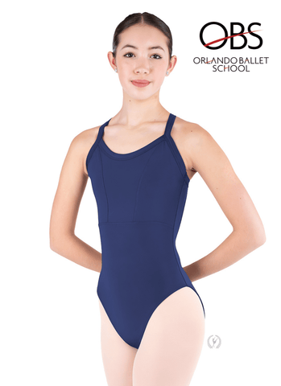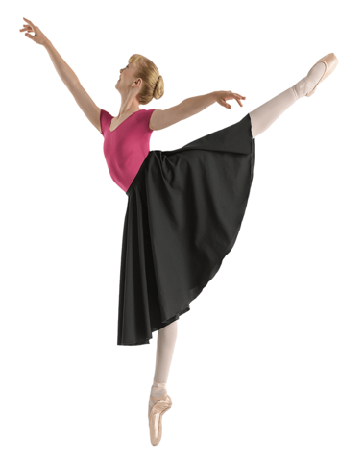
- Pink Split sole canvas or leather ballet shoes
- Students may opt for skin toned ballet shoes with matching skin tone tights

Academy B
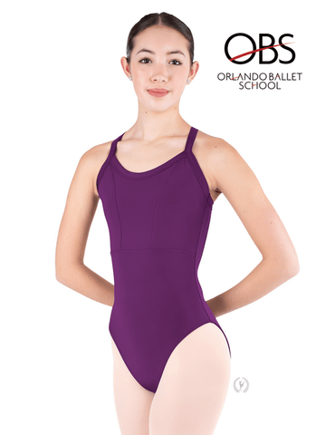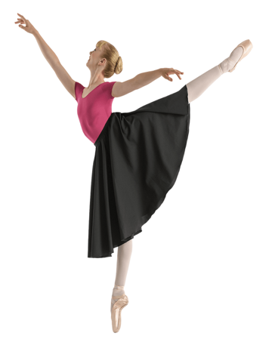
- Pink Split sole canvas or leather ballet shoes
- Students may opt for skin toned ballet shoes with matching skin tone tights
Men

- White shirt with black or grey tights
- Ballet shoes and socks should be matching (black socks with black shoes, white socks with white shoes).
- Dance Belt
- Leather belt to hold and roll down tights.
Absence and Attendance
- The artistic staff highly encourage all students to attend all classes to achieve the intended training and physical development of their program.
- Participation in all scheduled classes, including contemporary, character, partnering, lunch and learns and more is required as an academy student.
- Attendance is taken by instructors for each class; records of a student’s attendance can be found in the parent portal.
- All planned absences should be submitted in advance by the student or their family in the parent portal. This will automatically mark the student absent and notify instructors.
- Students who accrue a considerable number of absences, both excused or unexcused may not be eligible to participate in the spring showcase or be considered for the program the following year.
- Students who stop attending classes will be administratively withdrawn after 4 weeks of accrued absences.
- If a student is late to class, they may not be able to participate at the instructor’s discretion, where they may be asked to observe.
- Students should not attend class if they are sick and should be fever free for 24 hours without the use of fever reducing medication to resume classes.
- Make up classes are not available for student absences.

Medical Conditions, Allergies and Injuries
- All Academy Students are required to submit the physician release form prior to beginning their program and submit health insurance information.
- Any medical conditions that affect a student’s wellbeing or participation in classes should be provided in advance.
- Students with allergies or emergency prescriptions should list all details in their profile.
- OBS must be notified in writing regarding all requested accommodations and needs related to any condition in advance of the school year, or as soon as a condition develops.
- OBS is not responsible for administering medications or managing student medical conditions.
- Any student who has a chronic injury or becomes injured before or during attendance in their programming must notify the administrative team immediately by emailing registrar@orlandoballet.org.
  - A doctor’s note must be provided with date of visit information, expected recovery dates or dates of specific restrictions, with the restrictions included.
  - Students must provide updates on their recovery, or any changes to their restrictions.
  - Unless stated in restrictions, students should observe all classes during their recovery that do not conflict with any appointments.
  - If an injury requires 6 weeks or more of recovery:
    - Senior faculty will consult with the student and their family regarding a leave of absence from the program based on the level of participation and parameters provided by their medical provider.
    - During a leave of absence, students do not attend classes and should be at home to focus on recovery for the duration of the leave of absence set in place during consultation.
    - Tuition is not billed during the leave of absence.
    - Following 6 weeks, OBS will consult with the student and their family regarding their recovery and ability to resume programming, or if a withdrawal from the school will be necessary to continue healing from the injury.
Safety & Security
Orlando Ballet School has the following safety features in place at our facility:
- Security Cameras and Security team in the evenings.
- Auto lock features on studio doors
- All entrance and exits are always locked, and all visitors and guests require check in.
- An AED is located at entrance to school corridor
- Staff members are CPR certified
- Emergency exit and fire escape plans posted in each studio, with fire drills are scheduled throughout the year.
Drop-off, Pick up, Parking and Lobby Policies
- The facility opens 30 mins before class start time for student drop off. Students should not arrive more than 30 minutes prior to class start time. Facility does not open prior to 8:30am.
- Students should be picked up within 15 minutes of class end time. Students staying more than 15 minutes past class end time need to either check in to the study lounge, have an appointment or wait in the lobby until pick up.
  - Evening academy students should not be picked up more than 15 minutes past class end time due to building operating hours.
- Street parking is available in surrounding streets, please review posted signage and time restrictions. OBS is not responsible for any students or guests who obtain a ticket.
- Nearby parking garages are privately operated, students or guests who choose to park at these locations are subject to their fees and policies.
- Students may park in the Orlando Family Stage parking lot at no cost.
- The lobby is closed to all visitors, guests and parent/guardians during Academy A and B hours. All guests should have an appointment during these hours.
  - One parent or guardian may wait in the lobby during Evening Academy class hours.
Class Observation
- Class observation is available twice per year:
  - Week before Thanksgiving Break
  - Week before Spring Break
- Students may invite two guests to attend a class, and all guests are required to sign in.
- Additional observation days are not available and requests for observation days outside of these periods cannot be accommodated.
Evaluations
- Students will receive both a mid-year and year-end evaluation.
- Mid-year evaluations are provided in January and gauge progress as well as areas for improvement. Families will have the option to arrange a conference with faculty at this time.
- Year-end evaluations will follow Spring examinations, reviewing progression over the current school year and provide placement for the following season.
Performances
- Academy students will have multiple performance opportunities throughout the year including the Spring Showcase and Fall Repertory Concert, which are covered by program showcase fees.
- Company productions such as The Nutcracker or other programs where participation is available require participation fees. Not every production will have an opportunity, and students are selected either by audition, in class observation, or invitation.
- Academy students may have community performance opportunities. These opportunities are available on case-by-case basis. Casting and participation are at the discretion of faculty for any community performance opportunity.
Student Resources & Benefits
- Lockers
  - Students may request a locker for the school year term only through the locker request form.
  - Yearly rental fee is $25.
- Studios
  - Students may rent studios through the studio request form only. Same day requests may not be accommodated.
  - Rental fees are $35/hour or $20 per half hour.
- Snack Bar
  - Students may purchase concessions through our snack bar during breaks.
  - Cash, card and mobile payments are accepted.
- Study Hall
  - The study hall is open for students during their breaks or at the end of the day.
  - Students will need to sign in and out of the study hall
  - Students who have any academic requirement during their regular class time should provide notice in advance to use the study hall.
- Lost and Found
  - OBS stores lost found items for up to 3 months at a time at the front desk. These are then disposed of quarterly.
  - Students should not bring valuables to the facility, and we encourage students to label all items.
- Volunteer Medical Team
  - The Orlando Health volunteer medical team is available for students at specific days and timeslots.
  - While the medical team can assist with and triage most injuries or fatigue that occurs from daily training, any concerns or injuries that require further evaluation or treatment will be referred to appropriate parties to be addressed accordingly.
  - If a student requires further evaluation or treatment, the student and their family will be responsible for coordinating appointments to address the injury and seek further care. All medical conditions and injuries that occur are then subject to our medical condition/Injury policy as stated earlier in this handbook.
- Mainstage Production Tickets
  - Academy students receive 1 complimentary ticket to Orlando Ballet Mainstage performances. All restrictions and requirements to reserve the ticket will be provided to students via email, and students must follow box office protocol for requesting and receiving their ticket.
- Private Lessons
  - Students can request private lessons with OBS faculty to address specific needs or focus on assigned materials.
  - All private lessons require a studio rental and are subject to the studio rental fee and process.
International Students
- Orlando Ballet School is certified by SEVP Certified to issue F-1 visas to international students attending our Academy program.
- All international students are required to obtain a visa through Orlando Ballet School and cannot attend on a tourist visa.
- Full details on the International student visa process and procedures are available in our International student information sheet HERE.

Behavior and Etiquette Policies
Orlando Ballet School strives to provide the highest quality of training and the safest environment for all students. To do so, the School Staff asks for all parents, guardians, and students to help with creating this environment. OBS faculty, staff, and Director are always available to discuss any needs with a parent directly.
The School believes the following guidelines and commitment will help create this environment:
- Be respectful to all and courteous to fellow students, faculty and staff
- Be mindful and respectful of different viewpoints, cultures and lifestyles.
- Remain disciplined and focused on daily training.
- Ensure punctual transportation and attend all classes as scheduled.
- Monitor school calendars and schedules, be responsible for consistent participation in all scheduled events.
- Adhere by all safety protocols or any other protocols that are put in place to protect all students, staff and faculty.
- Understand the importance of practicing good hygiene, and do not attend classes while sick or contagious.
- Bring any concerns or potential issues to administrative staff in a timely fashion to ensure all students’ needs are being met and addressed. Students and their families can request an appointment to discuss any matters or their progress by reaching out to administrative staff.
Disciplinary Action and Zero Tolerance Policy
Students are expected to follow all rules and conduct themselves in ways that protect the interest and safety of all students, staff and faculty at Orlando Ballet School. Students who fail to abide by behavior and etiquette rules set in place by Orlando Ballet School will result in disciplinary action. The Orlando Ballet School disciplinary action plan is as follows:
- 1st offense: Verbal Warning.
- 2nd offense: Formal written Warning. Outlines previous offense and expectations of improvements needed to abide by policies. Notification will be provided to parent/guardian or to student age 18+.
- 3rd offense: Final Written Warning. Student will be asked to leave program at the expense of the student and their family.

Orlando Ballet School may consider some infractions a second or third offense. The decision to warrant any situation, behavior or infraction a 2nd or 3rd offense before issuing a 1st offense is at the sole discretion of any Orlando Ballet School staff or faculty member.
Orlando Ballet School also practices a Zero Tolerance Policy for more serious offenses that will result in immediate expulsion from the program without consideration of a 1st or 2nd offense. Serious offenses include, but are not limited to:
- Any form of theft
- Destruction of, misuse or unauthorized use of Orlando Ballet property
- Any form of violence, harassment, or discriminatory remarks, both verbal and physical to any student, staff or faculty member.
- Possession of firearms or weapons anywhere on Orlando Ballet property and other locations of an Orlando Ballet School event.
- Use or possession of drugs, alcohol, or comparable substances
- Any other offense which Orlando Ballet School management in its sole discretion warrants termination
Violation of any these rules are subject to immediate dismissal of the student at the expense of the student and their family.

